Mireto

AI DISRUPTION ASSESSMENT
AI Disruption Snapshot
Lanternfield Entertainment, Inc.
Arts, Entertainment and Recreation

Prepared by Kestrel Ridge Advisory using Mireto
November 6, 2026

Fictional sample. Every client, figure and source in this sample is invented. Not a client engagement.

CONFIDENTIAL mireto.ai

57/100  AI DISRUPTION SCORE  Based on public sources | Moderate AI Disruption  EXPOSURE LEVEL

Scoring
The AI Disruption Score (0 to 100) measures how much AI is likely to reshape the operating environment. It is not a measure of AI readiness or maturity, and not a verdict of good or bad: a high score means AI bears heavily on the business, creating both threats and opportunities. It combines eight weighted dimensions, each scored 1 to 10. Higher means more exposure, except the three defensibility dimensions (switching cost, regulatory moat, brand and trust), where a lower score means stronger protection. Proprietary data is scored as the stakes of the data arena, not as an advantage.

KEY FIGURES
Revenue · FY2025  US$410M FY2025  Source: entered at scan start | Headcount · FY2025  6,200 team members FY2025  Source: entered at scan start  May include contractors and deployed staff.

1. Executive Summary
Lanternfield faces moderate AI disruption. Its venues sell an experience that software cannot replace, but the channels that bring guests in are moving to AI assistants.
The sharpest exposure is in booking and pricing. Rivals have begun to price game cards by the hour, and families are starting to ask assistants to choose a party venue.
The strongest asset is the loyalty data. Few venue operators hold play history at the level of the individual card.

2. Exposure by Dimension
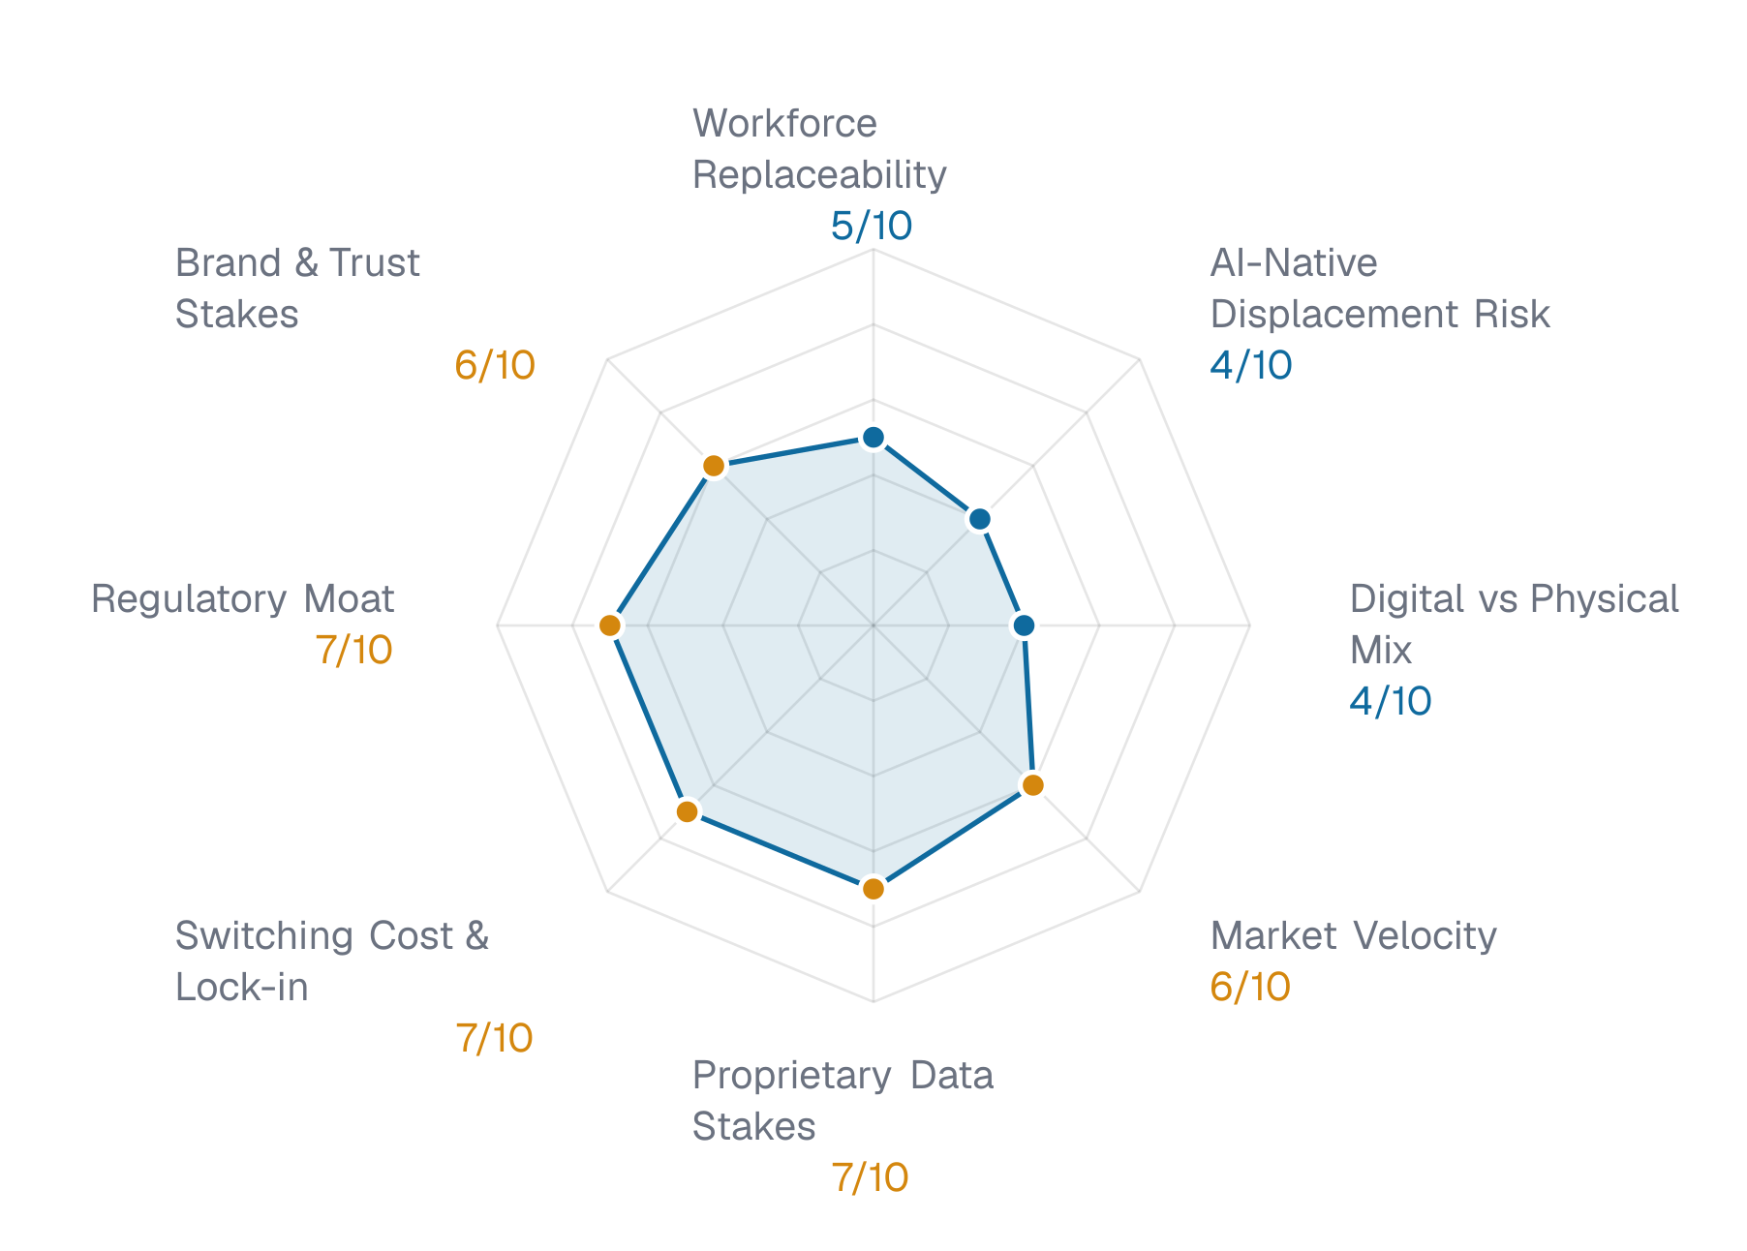

Workforce Replaceability 5/10 Low-Moderate
Much of the frontline work at a family entertainment venue is guest-facing and physical. The tasks AI can take on sit around it: rostering, booking inquiries, card-balance questions and back-office reporting.
Exposure · Weight 1.5x · Contribution 7.5pts

AI-Native Displacement Risk 4/10 Low-Moderate
A venue sells a place to be together, which software cannot replace. The exposure is in how guests find and book it, and in how it prices a visit.
Exposure · Weight 1.5x · Contribution 6pts

Digital vs Physical Mix 4/10 Low-Moderate
The core product is physical. The digital layer is the booking channel, the loyalty program and the app, and that layer is where AI changes the most.
Exposure · Weight 1x · Contribution 4pts

Market Velocity 6/10 Moderate
Operators in the category are testing AI in pricing and queue management. The moves are early, and a venue that waits will meet guests who already expect them.
Exposure · Weight 1.5x · Contribution 9pts

Proprietary Data Stakes 7/10 Significant
The loyalty program holds play history at the level of the individual card. That is a rare asset for the category, and it matters more as pricing and offers become data-led.
Stakes · Weight 1.5x · Contribution 10.5pts

Switching Cost & Lock-in 7/10 Significant
A family can change venues at no cost. The loyalty balance is the only real tie, and it is a modest one.
Defensibility · Weight 1x · Contribution 7pts · Weak protection – high disruption exposure

Regulatory Moat 7/10 Significant
Venue operations are subject to local safety and licensing rules. These do not protect against a new booking channel or a pricing change.
Defensibility · Weight 1x · Contribution 7pts · Weak protection – high disruption exposure

Brand & Trust Stakes 6/10 Moderate
Families choose a venue they trust with their children. A fair-pricing or safety lapse costs more than it would in a category where the stakes are lower.
Defensibility · Weight 1x · Contribution 6pts · Moderate protection – some disruption exposure

3. Threats
Ranked by severity.

T1 CRITICAL 0-12 months
Rivals price game cards by the hour
Competitors that adjust game-card bonuses by hour and weekday keep yield that flat pricing leaves behind. Harbor Pine Amusements piloted AI-driven hour-by-hour card pricing at a small number of venues ^{[1]}. Lanternfield prices cards the same way all week.

T2 HIGH 6-12 months
AI booking assistants shortlist rival venues
Families increasingly ask AI assistants to shortlist party venues. A venue whose packages are not published in a form an assistant can read may drop out of the shortlist before the family reaches its site. Party bookings are where group revenue concentrates.

T3 MEDIUM 12-24 months
Home gaming absorbs the casual weekday visit
Console and mobile titles offer the short social play that once drove weekday traffic to venues. Weekday visits are the most price-sensitive part of the week, so this pressure lands first on the quietest days.

T4 MEDIUM 12-24 months
Live wait estimates reset guest expectations
Quillmoor Parks uses AI wait-time forecasting to show guests a live estimate for lanes and simulators across its venues ^{[2]}. Guests who see this elsewhere expect it everywhere. No comparable feature was found for Lanternfield.

T5 LOW 24-36 months
Frontline scheduling falls behind AI-run peers
Operators that forecast demand by the hour staff fewer idle shifts. Manual rosters leave that gap open, and the cost shows up as either idle labor or thin cover on busy nights.

T6 LOW 12-24 months
Prize redemption fraud scales with automation
Automated play scripts can farm redemption tickets on skill games. Tools that watch play patterns exist. None is visible in the public material reviewed for Lanternfield.

4. Opportunities
Ranked by impact.

O1 HIGH 6-12 months
Dynamic game-card pricing lifts yield
Adjusting game-card bonuses by hour and weekday recovers yield on quiet periods. It answers the pricing threat directly. The size of the gain depends on volumes Lanternfield has not published, so this Snapshot does not put a figure on it.

O2 HIGH 12-24 months
Loyalty data personalizes offers
The loyalty program records every card swipe. Offers built on play history can bring lapsed members back on quiet days. Few venue operators hold play history at the level of the individual card.

O3 MEDIUM 0-6 months
Machine-readable party packages
Publishing party packages in a structured form lets AI booking assistants quote and book them. This is the direct answer to the booking-assistant threat.

O4 MEDIUM 6-12 months
Demand-led shift scheduling
Forecasting demand by the hour from sales and booking data lets managers staff to the curve. The data already exists in the point-of-sale system.

O5 MEDIUM 12-24 months
Live wait estimates in the app
Showing live wait estimates for lanes and simulators meets the expectation peers have set. It builds on the demand forecast above.

O6 LOW 12-24 months
AI-assisted game maintenance
Sensor and service logs can predict which games will fail. Fewer dead games on a busy night protects revenue per visit.

5. AI Activity
One public line: a loyalty data migration to a new cloud data platform, which brings card-level play history into one place. No named AI feature was found in the company's newsroom or careers pages. The platform itself is not AI, but it holds the data that pricing, offers and scheduling would need.
- Lanternfield moved its loyalty program to a new cloud data platform, bringing card-level play history for every member into one place. (Cloud data platform)^{[3]}
Searched public sources for: major enterprise AI platforms.

6. Peer Intelligence
What industry peers are doing with AI.

Harbor Pine Amusements INDUSTRY PEER
- Harbor Pine Amusements piloted AI-driven hour-by-hour game-card pricing at a small number of venues, adjusting card bonuses by hour and weekday [1].

Quillmoor Parks INDUSTRY PEER
- Quillmoor Parks uses AI wait-time forecasting to show guests a live estimate for lanes and simulators before they join a queue [2].

AI Adoption Gap
The peers show named AI features in guest-facing operations. Lanternfield shows none in the public material reviewed. Both peer moves touch what a guest notices first: what a game card costs and how long the wait is. Lanternfield's public material describes a loyalty data migration and no feature a guest would see.

Next Steps
1. Share this Snapshot with the leadership team.
2. Agree which threats and opportunities to act on first.
3. Move on to the Leadership Lens, then the AI Disruption Analysis, then the AI Strategic Blueprint (Strategy Canvas, Transformation Roadmap and Executive Presentation).

Sources
[1] Sample Trade Review, June 2026. “Sample Trade Review: Hourly card pricing on trial”. https://sampletradereview.example/2026/06/hourly-card-pricing
[2] Sample Trade Review, May 2026. “Sample Trade Review: Live wait estimates reach more venues”. https://sampletradereview.example/2026/05/live-wait-estimates
[3] Lanternfield newsroom (fictional). https://lanternfield.example/news/loyalty-platform

About This Document
What this is. An outside-in view of where AI is most likely to reshape Lanternfield Entertainment's competitive landscape, scored across eight dimensions.
How we built it. We researched public sources – the organization's website, press, job postings, peer firms and sector signals – plus any documents or notes supplied before the assessment started, then scored eight weighted dimensions against calibrated rubrics. Threats and opportunities were drawn from that evidence and run through an automated fact-check before publication. Sources are numbered in the text and listed at the back.
Limits to keep in mind. Everything here is based on what's publicly visible, plus anything supplied directly. Work that hasn't surfaced publicly or been shared won't show up here, so the real exposure may differ from what we've inferred.
How to use it. Start with the overall score and band, then read the threats and opportunities that feel most relevant – not necessarily the highest-rated ones.

Methodology

Data Sources
The analysis draws on multiple data sources: automated website crawling and technology stack analysis, public data research including financial filings, news coverage, job postings, and competitor intelligence via the Brave Search API. Scores are calibrated against a fixed reference set of 20 organizations across global sectors. All data is point-in-time and reflects publicly available information at the date of analysis. For US organizations, workforce and role analysis also draws on O*NET occupational data (onetcenter.org, U.S. Department of Labor), used under CC BY 4.0. Employment, wage and occupational-projection figures for US roles are sourced from the U.S. Bureau of Labor Statistics (Occupational Employment and Wage Statistics, and Employment Projections), public domain.

Peer Intelligence
Peer organizations are identified through industry classification and competitive analysis. AI adoption signals are detected from public sources including press releases, job postings (AI/ML roles, data engineering positions), technology partnerships, product announcements, and industry conference presentations. Signals are point-in-time and may not reflect internal AI programs that have not been publicly disclosed.

Limitations
This analysis is based on publicly available information. It does not incorporate proprietary organizational data unless provided through the strategy workshop process. Any financial estimate is a directional indicator derived from public data and stated assumptions, not a forecast. The AI disruption landscape is evolving rapidly: scores and analysis reflect conditions at the date of generation and should be reviewed at least quarterly.

Score Band
55–64 Moderate. The organization faces meaningful AI disruption across multiple dimensions. Competitors are actively deploying AI capabilities, customer expectations are shifting, and operational efficiency gaps are becoming visible. The pace of change is accelerating and the cost of delay is growing. Action is needed within the next 6-12 months on priority areas. The organization should move beyond exploration into structured AI deployment, starting with the highest-impact use cases identified in the threat and opportunity analysis. Delay beyond 12 months risks competitive erosion that becomes progressively more expensive to reverse.
Scale: 0–39 Low · 40–54 Low-Moderate · 55–64 Moderate · 65–74 Significant · 75–89 High · 90–100 Very High

Glossary
DIMENSION | WHAT IT MEASURES
Workforce Replaceability | Measures what proportion of the organization's workforce performs tasks that AI can automate or augment – data entry, document processing, routine analysis, customer inquiries, scheduling, and other structured workflows. Higher scores indicate a greater share of roles with high automation exposure.
AI-Native Displacement Risk | Assesses the risk that AI-first entrants could deliver the same core value proposition at dramatically lower cost and with fewer people. This measures how vulnerable the business model is to disruption by lean, technology-native competitors who build AI into their operations from day one.
Digital vs Physical Mix | Evaluates how digital the organization's core operations are. Organizations with primarily digital workflows (data processing, online services, digital communications) have significantly more surface area for AI disruption than those with physical operations (manufacturing, logistics, in-person services).
Market Velocity | Measures how rapidly competitors and the broader market are adopting AI. In fast-moving sectors, delay is exponentially costly – each quarter of inaction allows competitors to compound their AI-driven advantages in cost, speed, and customer experience.
Proprietary Data Stakes | Assesses how decisive proprietary data plus AI is in this sector, and what the organization's data position means either way. Organizations holding large, high-quality datasets specific to their domain can press the advantage: that data becomes a moat against disruption. Organizations without such data face the gap in reverse.
Switching Cost & Lock-in | Measures how easily customers could leave for an AI-native alternative. Low switching costs mean customers can move quickly when a better AI-powered option appears. High switching costs (long-term contracts, data lock-in, regulatory barriers) provide a buffer against disruption but should not be mistaken for immunity.
Regulatory Moat | Evaluates how much regulation protects the business from new AI-powered entrants. Heavily regulated industries (financial services, healthcare, education) have natural barriers that slow AI-native disruption, but regulation also slows the incumbent's own AI adoption. A high score means less regulatory protection.
Brand & Trust Stakes | Measures how much the organization depends on human trust, brand reputation, and relationship-based value that AI cannot easily replicate. Industries where trust is paramount (financial advice, healthcare, legal) retain some natural defense against AI disruption – but this defense erodes as AI systems demonstrate competence.

Disclaimer
Fictional sample. Every client, figure and source in this sample is invented. Not a client engagement.
Kestrel Ridge Advisory prepared this document for Lanternfield Entertainment, Inc. using an AI-assisted assessment platform. It may draw on public information and on material the client supplied, which has not been independently verified. Any estimates are indicative, not forecasts. It is not financial, legal, investment or other professional advice; seek independent advice before acting on it. It is confidential to the client and may be shared with its leadership, board and advisors, but not published or distributed further without Kestrel Ridge Advisory's written consent. To the extent permitted by law, Kestrel Ridge Advisory accepts no liability for any loss arising from use of, or reliance on, this document.

